PART –A
Following Experiments No. 1 to 4 has to be performed using discrete components.
1.Amplitude Modulation and Demodulation:(a).Standard AM (b) DSBSC AM
2.Frequency Modulation Demodulation.
3. Pulse Amplitude Modulation and Demodulation.
4. Time Division Multiplexing and Demultiplexing of two bandlimited signals.
5. FSK generation and detection
6. PSK generation and detection
7. Measurement of frequency, guide wavelength, power, VSWR and attenuation in microwave test bench.
8. Measurement of directivity and gain of microstrip dipole and Yagi antennas.
9. Determination of
a. Coupling and isolation characteristics of microstrip directional coupler.
b. Resonance characteristics of microstrip ring resonator and computation of dielectric constant of the substrate.
c. Power division and isolation of microstrip power divider.

PART-B
Simulation Experiments using SCILAB/MATLAB/Simulink or LabView
1. Simulate NRZ, RZ, half-sinusoid and raised cosine pulses and generate eye diagram for binary polar signaling.
2. Simulate the Pulse code modulation and demodulation system and display the waveforms.
3. Simulate the QPSK transmitter and receiver. Plot the signals and its constellation diagram.
4. Test the performance of a binary differential phase shift keying system by simulating the non-coherent detection of binary DPSK.

1(a). AmplitudeModulation and Demodulation-Standard AM
AIM:To generate AM signal, information signal given the collector. Also, demodulate it. Measure the modulation index.
Components Required:
SL 100/BC 107transistor, resistors, capacitors, diode 0A79, connecting board, connecting wires and CRO.
Circuit Diagram:
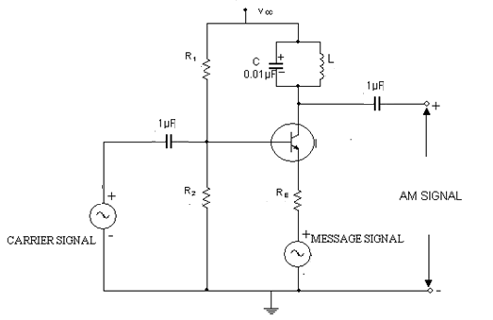
Vcc=5V, R1=100KΩ, R=39KΩ, Re=1KΩ, L=220µH
Message Signal with fm=2-3 KHz,
Carrier Signal with fc=75-100 KHz

Procedure:

1. Set up the circuit after verifying the condition of components.
2. Feed AF modulating signal (say, fm = 11kHz and Em= 11V ) using a function generator.
3. Adjust amplitude and frequencies of the AF and carrier signals and observe amplitude modulated waveform on the CRO.
4. Fix fmand fc. Note down Emaxand Eminof the AM signal and calculate modulation index according to the formula
m =(Emax – Emin) / (Emax+ Emin)
Here Emaxis the maximum of the positive envelope of the carrier andEminis the minimum of the positive envelope of the carrier.
5. Repeat for different values of Emand Ec. Observe the AM waveforms fordifferent values of m.
Demodulation Circuit:

Circuit diagram
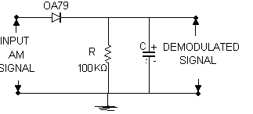
With C=0.1µF

Result:AM wave is generated with modulation index=_______ and demodulation is done using envelope detector

1(b). DSB-SC Modulation and Demodulation

Aim:To set up a balanced modulator circuit for double side band suppressed carrieramplitude modulator. To implement a demodulator to obtain the message signal.
Components required:
Name of the  Component/Equipment | Specifications/Range | Quantity
IC 1496 | Wide frequency response up to 100 MHz  Internal power dissipation – 500mw(MAX) | 1
Resistors | 6.8KΩ  10 KΩ, 3.9 KΩ  1KΩ,51 KΩ | 1  2 Each  2 Each
Capacitors | 0.1 μF | 4
Linear Pot | 0-50KΩ | 1
Circuit Diagram:
Procedure:

1. Connect the circuit diagram as shown in Fig.1.
2. An Carrier signal of 1Vp-p amplitude and frequency of 83 KHz is applied as carrier to pin no.10.
3. An AF signal of 0.5Vp-p amplitude and frequency of 5 KHz is given as message signal to pin no.1.
4. Observe the DSB-SC waveform at pin no.12
Waveform:
Result:
DSB_SC wave is generated using balanced modulator with carrier frequency fc=_____Hz and modulating signal frequency fm=_____Hz

2. FREQUENCY MODULATION AND DEMODULATION

Aim:
1. To generate frequency modulated signal and determine the modulation index and bandwidth for various values of amplitude and frequency of modulating signal.
2. To demodulate a Frequency Modulated signal using FM detector.
Components required:
Name of the  Component/Equipment | Specifications/Range | Quantity
IC 8038 | Operating voltage –Max-24 Volts  Operating current-Max.12.5 mA | 1
IC 565 | Power dissipation -1400mw  Supply voltage - ±12V | 1
Resistors | 15 K Ω, 10 K Ω, 1.8 K Ω,  39 K Ω, 680 Ω | 1,2,1  2,2
Capacitors | 100μF, 400µF,0.1µF,10µF | 1 Each
Linear Pot | 0-50KΩ | 1
Circuit diagram:
FM Modulation
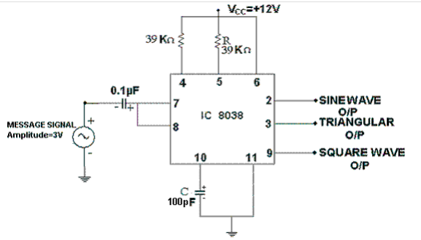

FM Demodulation:

Procedure:
Modulation:
- Before wiring the circuit, check all the components using multi meter.
- Make the connections as shown in circuit diagram.
- And observe the waveform at pin no.9, 3 and 2 on CRO that is square, triangular and sine wave respectively.
- Measure sine wave amplitude and frequency. It will be the frequency of carrier wave.
- Switch on the function generator and apply modulating signal of Vin (P-P) = 2V (P-P) and frequency in the range of 1kHz to 10kHz through RC circuit as shown.
- Observe FM wave output at pin 2. Draw output waveform and note down f_{max}and f _{min}.
- Calculate modulation index $β$ and transmission bandwidth B_{T}.
Demodulation:
1. Connections are made as per circuit diagram shown in Fig.3
2. Check the functioning of PLL (IC 565) by giving square wave to input and observing theoutput
3. Frequency of input signal is varied till input and output are locked.
4. Now modulated signal is fed as input and observe the demodulated signal (output) onCRO.
5. Draw the demodulated wave form
Waveform:
Result:Observed FM Wave and calculated$β$= ________ and B_{T} = ____________Hz

PULSE AMPLITUDE MODULATION
AIM:To conduct an experiment to generate PAM signal and design a circuit to demodulate the PAM signals.
COMPONENTS REQUIRED:
Sl.No. | Component | value | Quantity
1 | Transistor | SL100/BF194 | 1
2 | Capacitors | 0.1µf | 3
3 | Resistors | 10KΩ | 1
3 | Resistors | 22KΩ | 1
3 | Resistors | 4.7 KΩ | 1
3 | Resistors | 680 Ω | 1
4 | Diode | 0A79 | 1

CIRCUIT DIAGRAM:
DESIGN FOR DEMODULATOR:
fc>>1/RC, fc=15KHz and c =0.1µF
R=$\frac{1}{15KHZ X 0.1 µF}$ = 680Ω.
PROCEDURE:
- Make the Connections as shown in circuit diagram.
- Set the carrier amplitude to 2 Vpp and in the frequency of 5 kHz to 15 kHz.
- Set the i/p Signal amplitude to around 1V (p-p) and frequency to 2 kHz.
- Connect the CRO at the emitter of the transistor and observe the Pam waveform.
- Now connect the O/p(i.e. PAM) signal to the demodulation circuit and observe the signal if it matched plot the waveform
WAVEFORMS:

RESULT:The circuit to generate PAM signal and to demodulate the PAM signal were designed and the waveform were observed.

3.Time Division Multiplexing and Demultiplexing of two bandlimited signals.
Aim:
To design and demonstrate the working of time division multiplexing for Pulse Amplitude Modulated Signals using discreet components.

Components Required:
Resisters 22K-2, 1k- 2, transistor SL 00 – 2, IC 4051-2
Theory:
Time-division multiplexing (TDM) is a type of digital or (rarely) analog multiplexing in which two or more signals or bit streams are transferred apparently simultaneously as sub-channels in one communication channel, but are physically taking turns on the channel. The time domain is divided into several recurrent timeslots of fixed length, one for each sub-channel. A sample byte or data block of sub-channel 1 is transmitted during timeslot 1, sub-channel 2 during timeslot 2, etc. One TDM frame consists of one timeslot per sub-channel. After the last sub-channel the cycle starts all over again with a new frame, starting with the second sample, byte or data block from sub-channel 1, etc.
Application examples
- The plesiochronous digital hierarchy (PDH) system, also known as the PCM system, for digital transmission of several telephone calls over the same four-wire copper cable (T-carrier or E-carrier) or fiber cable in the circuit switched digital telephone network.
- The SDH and synchronous optical networking (SONET) network transmission standards, that have surpassed PDH.
- The RIFF (WAV) audio standard interleaves left and right stereo signals on a per-sample basis.
TDM can be further extended into the time division multiple access (TDMA) scheme, where several stations connected to the same physical medium, for example sharing the same frequency channel, can communicate. Application examples include:
- The GSM telephone system
Circuit Diagram:
Multiplexer
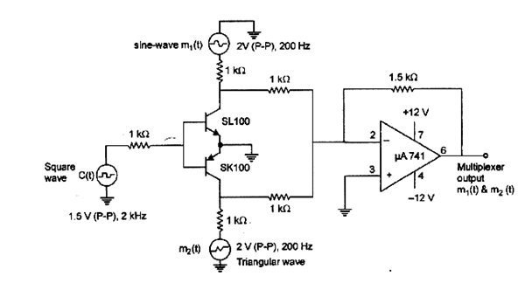
Demultiplexer
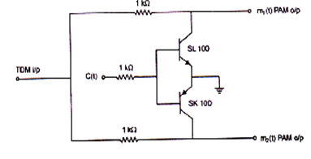
Procedure:
- Rig up the circuit as shown in the circuit diagram for multiplexer.
- Feed the input message signals m1 and m2 of 2 to 4V(p-p) at 200Hz.
- Feed the high frequency sampling signal of 4V (p-p) at 2KHz.
- Observe the multiplexed output.
- Rig up the circuit for demultiplexer.
- Observe the demultiplexed signal output.
Expected Waveform:
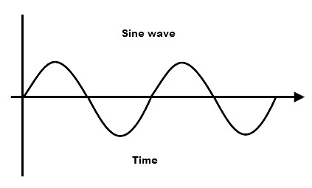
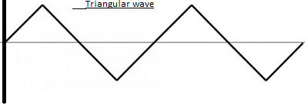
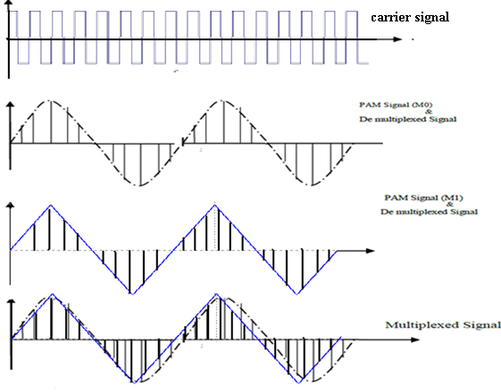
RESULT:

4. FSK generation and detection
Aim:
To design and study the working of FSK modulation and demodulation with the help of a suitable circuit.
Theory:
As its name suggests, a frequency shift keyed transmitter has its frequency shifted by the message. Although there could be more than two frequencies involved in an FSK signal, in this experiment the message will be a binary bit stream, and so only two frequencies will be involved. The word „keyed‟ suggests that the message is of the „on-off‟ (mark-space) variety, such as one (historically) generated by a morse key, or more likely in the present context, a binary sequence. Conceptually, and in fact, the transmitter could consist of two oscillators (on frequencies f1 and f2), with only one being connected to the output at any one time. Unless there are special relationships between the two oscillator frequencies and the bit clock there will be abrupt phase discontinuities of the output waveform during transitions of the message.
Bandwidth:
Practice is for the tones f1 and f2 to bear special inter-relationships, and to be integer multiples of the bit rate. This leads to the possibility of continuous phase, which offers advantages, especially with respect to bandwidth control. FSK signals can be generated at baseband, and transmitted over telephone lines (for example). In this case, both f1 and f2 (of Figure 2) would be audio frequencies. Alternatively, this signal could be translated to a higher frequency. Yet again, it may be generated directly at carrier frequencies.
Design:
- Modulator.
R_{C}=V_{CC}-V_{CE}/(I_{C})=1kΩ
R_{B}=$\frac{Vin-Vbe}{Ib}$=10KΩ
- Demodulator.
Low pass filter
f_{c}=2KHz, C=0.1µf
f_{c}=$\frac{1}{2πRC}$
R=7.9KΩ (Choose 10KΩ)
Envelope Detector.
$\frac{1}{fm}≪RC≪\frac{1}{fc}$
f_{m}=200Hz, f_{C}=10KHz.
Hence C=0.1µf, and R=10KΩ
Circuit Diagram:
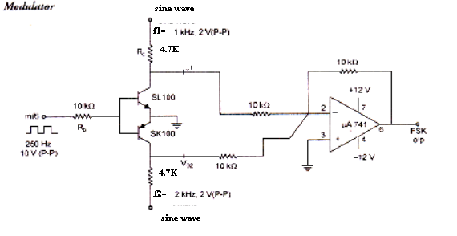
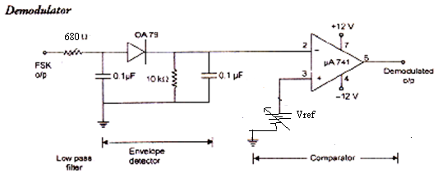
Procedure:
1. Rig up the modulator circuit as shown in the figure.
2. Apply carrier of amplitude 2 V(P- P) and frequency 1 kHz.
3. Apply carrier of amplitude 2 V(P- P) and frequency 2 kHz.
4. Apply message signal of amplitude 10 V(P - P) and frequency of 250 Hz. .
5. Observe ASK outputs at each collector of transistor, and also observe FSK output at pin 6 of op-amp.
6. Connect demodulator circuit.
7. Observe the demodulated output on CRO.
Waveforms:
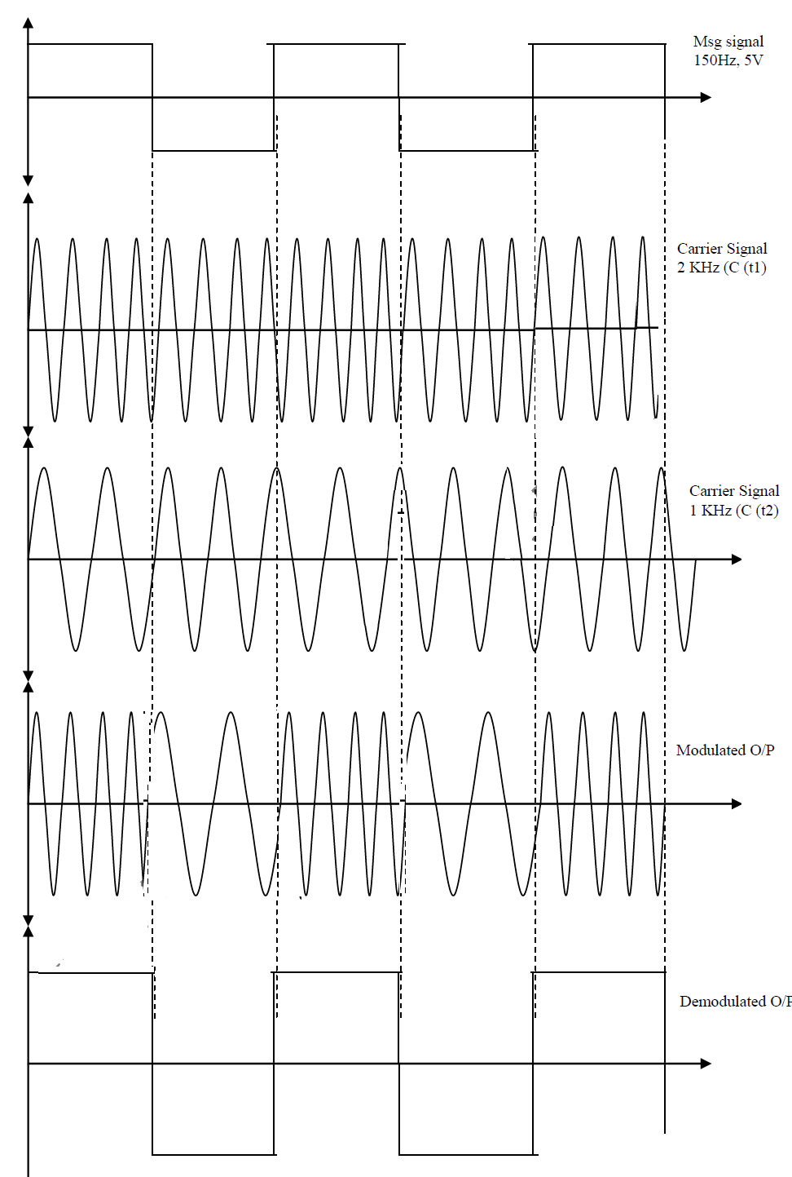
Result:

5.PSK generation and detection
Aim: To design and study the working of PSK modulation and demodulation using suitable circuit.
Theory:
Phase shift keying is one of the most efficient digital modulation techniques. It is used for very high bit rates. In PSK, the phase of the carrier is modulated to represent Binary values. In BPSK, the carrier phase is used to switch The phase between 00 and1800 by digital polar Format. Hence it is also known as phase reversal keying. The modulated carrier is given by:
Binary 1: S (t) = A_{c max}. Cos. (2πfct)
Binary 0: S (t) = A_{c max}. Cos. (2πfct + 180)
= - A_{c max}. Cos. (2πfct)
Design:
For modulator :
V_{C=} 5V_{P-P,} V_{m=} 8V_{p-p} , f_{m}= 100Hz, f_{c =} 1khz,
Assume hfe=β= 50, Vbe(sat)=0.8V, Vce(sat)= 0.2V, Ic= 10 ma= Ie,
Vm(peak)= IcRc+Vce(sat)…i.e5= IbRb+0.8
Ib=4.2/RB (β=50, Rb=22kΩ(63kΩmax value));
Vc(peak)= IcRc+Vce(sat)+IeRe; Ie=Vc(p)- VCE(sat)/Re…i.e 1.8/Rc
Ib>Ic/β…i.e 4.2/RB>1.8/Rcβ
Assume Re=4.7kΩ therefore Rb=2.2kΩ
For demodulator:
1/f_{m} >RC> 1/Fc1
3.3ms>RC>1ms
Let Rc= 2.2ms, C=0.2µf, R=10kΩ

Circuit Diagram:
Modulation:

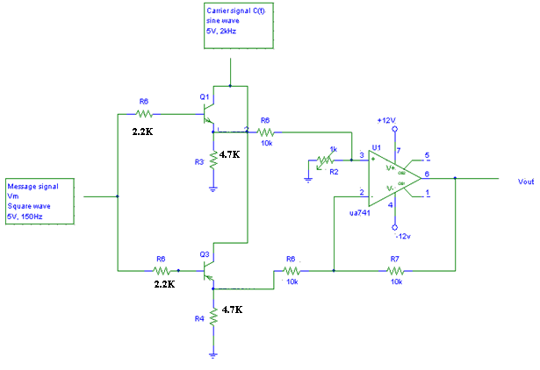Demodulation: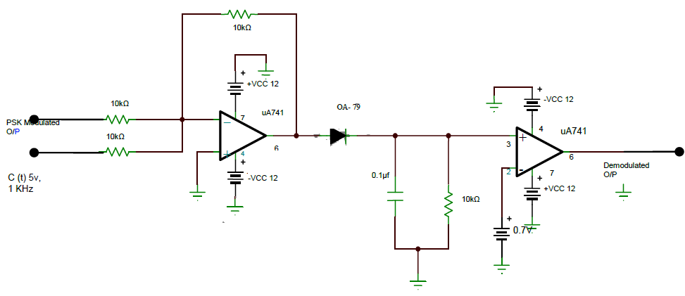

Inverting summing amplifier Envelop detector Comparator

Procedure:
1) The connections are made as per the circuit diagram.
2) A sine wave of amplitude 5v and 2kHz is fed to the Collector of the transistor as carrier.
3) the message signal, a square wave of amplitude 5V and 150Hz is fed to the base of the transistor.
4) The BPSK wave is observed at pin 6 of the op-amp IC 741.
5) The demodulation circuit is also connected.
6) BPSK wave obtained is fed as input to the demodulation circuit.
7) The demodulated waveform is observed
8) All the required waveform to be plotted.
Waveforms: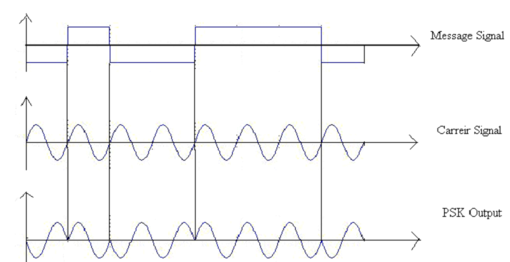
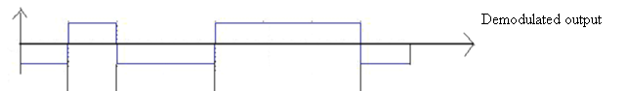

Result:

6.MEASUREMENTS USING MICROWAVE TEST BENCH.

Aim:Measurement of frequency, guide wavelength, power, VSWR and attenuation in microwave test bench.
Components Required
1. Klystron Power supply
2. Klystron mount
3. Isolator
4. Pin modulator
5. Variable Attenuator
6. Frequency meter
7. Slotted probe carriage
8. Tunable detector
9. VSWR meter
10. CRO

THEORY:-

BLOCK DIAGRAM
1963, J.B. Gunn discovered the bulk TRANFERRED ELECTRON EFFECT in Gallium Arsenide which is a semiconductor material.Si & Ge are called INDIRECT GAP semiconductors because the bottom of the conduction band does not lie directly above the top of the valence band.In GaAs the conduction band lies directly above the top of the valence band. The lowest energy conduction band in ga as is called as PRIMARY VALLEY. Gunn while measuring the current density J as a junction of electric field E in a Gallium Arsenide n-type specimen discovered that after a threshold field Eth is reached, the current in the specimen suddenly becomes oscillatory w.r.t. time and these oscillations are in the microwave frequency range. This effect is called “GUNN EFFECT”.
Gunn diodes are operated in two modes:-
1. The Gunn mode or the transit time mode
2. The LSA mode ( or limited space charge accumulation)

The Gunn diode is a bulk device i.e. it does not contain any junction but it is a slice of n-type GaAs . Hence it is a reversible device and can be operated in both directions.

Experimental Procedure:
1. Set the cooling fan to be blow air across the tube.
a. Set Beam voltage control knob fully anticlockwise (Off),
b. Repeller voltage to 3/4 clockwise.
c. Set modulation selector switch to AM- MOD position. Keep AM-MOD amplitude knob and AM-FREQUENCY knob at mid-position.
d. Volt/Current switch of the display to current position. Set display to read Beam voltage.
2. Wait for some 10 seconds; let the tube warm up and power supply get properly stabilized.
3. Slowly vary the beam voltage knob clockwise and set beam current to 19 or 20mA. The corresponding beam voltage would be around +290v.
4. Observe the demodulated square wave available at the detector o/p using a CRO. By adjusting the AM-MOD amplitude knob and the Reflector (repeller) voltage knob at a maximum o/p level on the CRO.

Procedure:
(A)To Find Guide Wavelength (Λg) And Operating Frequency (F_{o})
2. Set the GUNN bias in such a way that the diode operates in Negative Resistance region.
3. Tune the crystal detector such that the demodulated square wave o/p is maximum.
4. Short circuit the load end of the slotted line and calculate the count of the slotted line scale.
5. Without disturbing the GUNN bias, rotate the frequency meter till a dip in square wave is observed on CRO.
6. At that point read the Frequency meter to obtain the operating frequency of the gunn diode(fo).
7. The above steps are called as frequency determination using the direct method.
8. Locate a maxima on the CRO.This is also called a node.
9. Move the slotted line carriage to any node or antinode and note down the first reading as X1.
10. Move the slotted section to the immediate next node or antinode and note down the 2nd reading X2.
11. Guide wavelength (λg) is twice the difference of X1 and X2 i.e. λg = 2( X2 –X1)
Calculation:
Λc = 2a, 1/λ²₀ = 1/λ²g + 1/λ²c The value “a” is the width of the waveguide known to us as 2.3cm., therefore λc = 2X2.3 = 4.6 cms.
( b) To Find VSWR :-
(i) Direct method:-

1. Set the GUNN diode in the negative resistance region.
2. Locate any Maxima in the slotted line V_{max}.
3. Adjust the gain control knob of VSWR meter so that the pointer reads VSWR=1dB
4. Move the carriage to V_{min} position
5. Move the slotted line section in any direction until the pointer deflects suddenly kicks back from the value which is the VSWR.
6. The VSWR meter reading at the kick back point gives the VSWR.

( ii) Double Minima method:-
1. Measure λg following appropriate procedure.
2. Locate any minima and note down the corresponding power in db.
3. Move the slotted line section to the right till power increases by 3 dB(X1) and bring it back.
4. Move slotted line section to the left till power decreases by 3 dB (X2)
5. If distance between two points is d , then VSWR=λg/πd,
Where d=( X2 –X1) .

RESULT:
Frequency, f0 =
Guide wavelength, λg
VSWR (direct method) =
VSWR (double minima method) =
Power and Attenuation:
Screw gauge readings | Attenuation loss in dB

7.DIRECTIVITY & GAIN OF ANTENNAS

Aim: Measurement of directivity and gain of microstrip dipole and Yagi antennas.
Components Required: Power supply, VCO, 50 ohm transmission line, dipole antenna, yagi antenna, oscilloscope and VSWR meter.
Theory: The simplest practical antenna is the half wave dipole. In its original form it consists of two thin straight wires, each λ/4 in lengths, by a small gap. For this simple antenna, under fairly realistic approximations, closed form expressions are available for radiated fields, power, directivity etc.
The important feature of Yagi antenna is that it is an end-fire antenna, ie the direction of maximum radiation is tangential to the plane formed by the parallel antenna elements.
The design of a rectangular microstrip patch antenna begins with (a) choice of a substrate, (b) selecting the feed mechanism, (c) determining patch length L, (d) determining patch width w and (e) selecting the feed location.
Procedure:
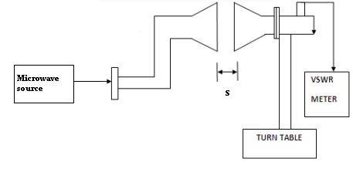
- Setup the system as shown in the figure for a standard dipole antenna.
- Keeping the voltage at min, switch on the power supply and keeping the gain control knob maximum, switch on VCO.
- Vary the tuning voltage and check the output for different VCO frequencies.
- Keeping at the resonant frequency calculate and keep the min distance for field between the transmitting & receiving antennas using the formula
S=2d²/λ
Where d is the length of the dipole and λ = c/f = 6cm. The calculated value is 2.25cm. Where L is the length of the dipole.
- Keeping the line of sight properly (0 degree at the turn table)
- Note the readings on the CRO, convert the voltage reading reading into dB by using the formula 20 log (V/V0) where V0 = voltage at zero degree.
- Rotate the turn table in clockwise & anti-clockwise for different angle of deflection & tabulate the output for every angle(Eф).
- Plot a graph : angle vs output .
- Take a reading in the E and H planes.
- Find the half power beam width (HPBW) from the points where the power becomes half(3db points or 0.707V points)
Directivity of the antenna can be calculated using the formula :
Generraly/Practically Directivity is given by
D=$\frac{32400}{θE θH}$
Where HPBW is the half power beam width in degrees, Find out two HPBW in two planes one principal plane and the other orthogonal plane. Em & Eф are the output signals at the receiving antenna for 0 degree and for different angles respectively.
- Gain of the antenna can be calculated using the formula :
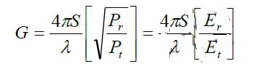
Gain in dB =10 log G
Where Et and Er are the signal strength measured using an oscilloscope at the transmitting end at the receiving end respectively, when the line of sight is proper. S is the actual distance kept between the antennas and λ is the wavelength found using the formula λ=c/f (f = frequency of operation)
- Repeat the experiment for patch antenna and a yagi antenna. Note: For microstrip antenna

Radiation Patterns of Different Antennas:
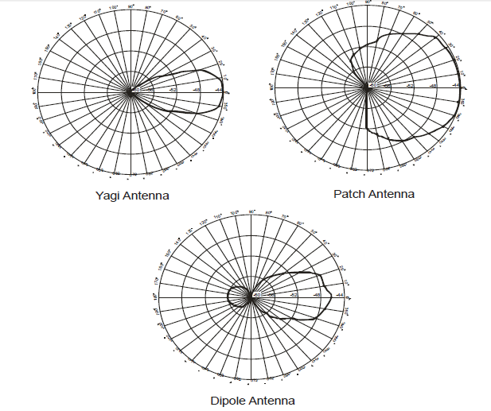
Tabular Column:
Angle in degree | VSWR Meter Reading
 | Output (R) | Output(L)
0
5
10
-
-
-
80

Result:

Experiment No.08a
Determination Of Coupling And Isolation Characteristics Of a Strip-Line Directional Coupler
Aim:- To determine the coupling and isolation characteristics of a stripline ( or microstrip) Directional coupler.
Components Required:
1. Power Supply
2. VCO
3. 50 ohm Transmission line
4. Branch line coupler
5. Parallel line in coupler
6. 50 ohm terminations
7. Cables with SMA connector
8. Oscilloscope / VSWR meter / Power Meter
Block Diagram:
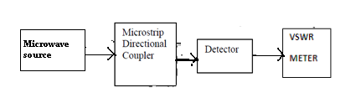
THEORY:-
A two stub branch line coupler is a fundamental direct coupled structure in which the main line is directly bridged to the secondary line by means of two shunt branches. The length of each branch and their spacing are all quarter Wavelength in the transmission medium at the center frequency f0. In a parallel coupled directional coupler the main length “l” of the coupled line section is quarter wavelength in the transmission medium at the center frequency f₀. All inputs and outputs lines have the same characteristic impedance
Procedure:
1. Set up the system
2. Keeping the voltage at minimum, switch on the power supply.
3. Insert a 50 ohm transmission line and check for the output at the end of the system using a CRO/VSWR meter/ RF power meter.
4. Vary the power supply voltage and check the output for different VCO frequencies.
5. Keep the VCO frequency constant, note down the output. This value can be taken as the input to the power divider.
6. Replace the 50 ohm transmission line with the Wilkinson power divider.
7. Tabulate the output at Ports 2 and 3.
8. Calculate Insertion loss and coupling factor in each coupled arm.
9. Calculate the isolation between ports 2 and 3 by feeding the input to port 2 and measure output at port 3 by terminating port 1.
10. Repeat the experiment for different VCO frequencies

With RF Power meter :
Isolation (dB) = 10 log (P2/P3)
Power division(dB) at arm3 = 10 log (P3/P1)
Power division(dB) at arm2 = 10 log (P2/P1)

With VSWR meter :
Isolation (dB) = P3-P2
Power division(dB) at arm3 = P1-P3
Power division(dB) at arm2 = P1-P2

With Oscilloscope:
Isolation between port 2 and 3 = 20 log(V3/V2)
Coupling factor at arm 3(dB) = 20 log(V3/V1)
Coupling factor at arm 2(dB) = 20 log(V2/V1)

Result

8b&c.MICROSTRIP RING RESONATOR AND POWER DEVIDER
Aim:
1. To measure resonance characteristics of Microstrip Ring Resonator and determine dielectric constant of the substrate.
2. To measure power division and isolation characteristics of microstrip 3dB power divider.
Components Required: power supply, VCO, 50 ohm transmission line, ring resonator, 50 ohm terminations, cables with Oscilloscope/VSWR meter/power meter.
Theory: Microstrip is a type of electrical transmission line which can be fabricated using printed circuit board technology, and is used to convey microwave-frequency signals. It consists of a conducting strip separated from a ground plane by a dielectric layer known as the substrate. Microwave components such as antennas, couplers, filters, power dividers etc. The basic configuration, which consists of unidirectional coupling between a ring resonator with radius r and a waveguide. Defining that a single unidirectional mode of the resonator is excited, the coupling is lossless, single polarization is considered, none of the waveguide segments and coupler elements couple waves of different polarization, the various kinds of losses occurring along the propagation of microwave.
The open-end effect encountered in a rectangular resonator of the feed long gaps can be minimized by forming the resonator as a closed off. Such resonator is called as Ring resonator. The Ring resonator find applications in the design of filters, oscillator and mixers. Resonance is established when the mean circumference of the ring is equal to integral multiplies of guide wave length.
2πr_{o}= nλ_{o}= $\frac{n vo}{fo\sqrt{€eff}}$

Where ro = radius of the ring, n = mode number, €_{eff} = effective dielectric constant of the substrate.
Power Divider: The function of a power division network is to divide the input power into two or more outputs. As an equal split power divider, the power incident at port1 gets divided equally between the two output ports 2 & 3.

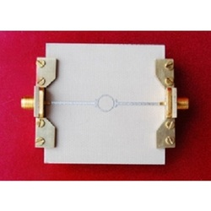
Microstrip ring resonator
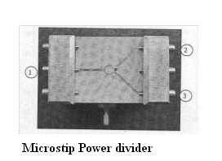
Experimental Set Up/Block diagram:
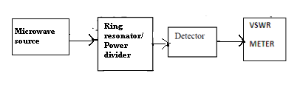

EXPERIMENTAL PROCEDURE:
1. Experiment set up as shown in fig.
2. Keep microwave generator in Internal AM mode.
3. Vary the RF out frequencies at 2.2GHz to 3GHz insteps of 0.1GHz and note down output detector power in VSWR meter.
4. Note down/ tabulate these results & note down the resonant frequency at which the output power maximum.
5. Plot the graph output power Vs frequency.
6. Determine dielectric constant of the substrate of Ring Resonator.

Power divider Characteristics:
1. Experiment set up as shown in fig.
2. Apply RF power to input port and observe the half power at 2 output port.
E.g. – If input power is -20dB, Output power is -23dB at each output port.
Calculations:
Dielectric constant of substrate
€_{r}= $\frac{2€eff-[1-1/A]}{1+1/A}$
Where A =$\sqrt{1+(10h/W)}$ area
W = Strip line conductor width = 1.847mm
h = Height of substrate = 0.762mm
$€eff=$(nv_{o}/2πr_{o}f_{o})²
n=1, v_{o}=3*10⁸ m/s, r_{o}=12.446mm
fo=Resonance frequency
Expected Graph:
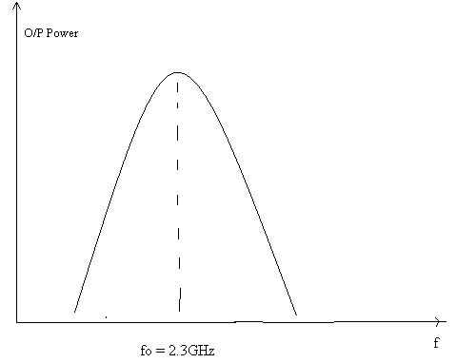
Table:
Rf signal f (Ghz) | Output power(Db)
2.1Ghz

RESULTS:

PART-B
Simulation Experiments using SCILAB/MATLAB/Simulink or LabView.
Experiment1
Simulate and also generate eye diagram for binary polar signaling.
Aim:Simulate NRZ, RZ, half-sinusoid and raised cosine pulses and generate eye diagram for binary polar signaling.

Theory: A line code is the code used for data transmission of a digital signal over a transmission line. This process of coding is chosen so as to avoid overlap and distortion of signal such as inter-symbol interference.
Non-return-to-zero (NRZ). The pulse amplitude is held constant throughout the pulse or bit period.
Return-to-zero (RZ). The pulse amplitude returns to a zerovolt level for a portion (usually one-half) of the pulse or bit period.
The half sinusoidal pulse is given by
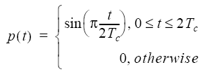
The raised cosine pulse has attractive properties. It is not normally used for transmission itself, but it appears as part of receiver processing of the closely-related “square root raised cosine” pulse. The square root raised cosine is the most widely used pulse shape in communications.
In telecommunication, an eye pattern, also known as an eye diagram, is an oscilloscope display in which a digital signal from a receiver is repetitively sampled and applied to the vertical input, while the data rate is used to trigger the horizontal sweep. It is so called because, for several types of coding, the pattern looks like a series of eyes between a pair of rails. It is a tool for the evaluation of the combined effects of channel noise and intersymbol interference on the performance of a baseband pulse-transmission system. It is the synchronized superposition of all possible realizations of the signal of interest viewed within a particular signaling interval.
Code:
Eyediagram:
clc;
closeall;
clearall;

%Generate 400 random bits
data = sign(randn(1,400));
%Define the symbol period
T = 64;
Td = 32;
%Generate impulse train
dataup=upsample(data, T);

%Return to zero polar signal
yrz=conv(dataup,[zeros(1,T/4) ones(1,T/2) zeros(1,T/4)]);
yrz=yrz(1:end-T+1);

%Non-return to zero polar signal
ynrz=conv(dataup, ones(1,T));
ynrz=ynrz(1:end-T+1);

%half sinusoid polar signal
ysine=conv(dataup, sin(pi*[0:T-1]/T));
ysine=ysine(1:end-T+1);

% generating RC pulse train and rolloff factor = 0.5
yrcos=conv(dataup, rcosfir(0.5, Td, T,1,'normal'));
yrcos=yrcos(2*Td*T:end-2*Td*T+1);

eye1=eyediagram(yrz,T,T,T/2);title('RZ eye-diagram');grid('on');ylim([-1.5,1.5]);xlim([-Td-2,Td+2])
eye2=eyediagram(ynrz,T,T,T/2);title('NRZ eye-diagram');grid('on');ylim([-1.5,1.5]);xlim([-Td-2,Td+2])
eye3=eyediagram(ysine,T,T,T/2);title('Half-sine eye-diagram');grid('on');ylim([-1.5,1.5]);xlim([-Td-2,Td+2])
eye4=eyediagram(yrcos,2*T,T); title('Raised-cosine eye-diagram');grid('on');ylim([-1.5,1.5]);xlim([-Td-2,Td+2])

Procedure:
- Write the code using Matlab simulation tool.
- Verify the program and check out the errors.
- Analyze the simulation output.
- Plot the graph/diagram using obtained output.

Eye Diagrams:
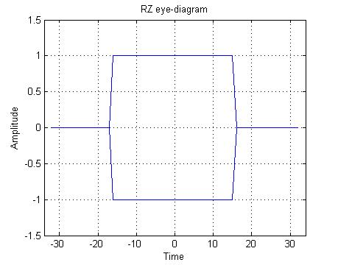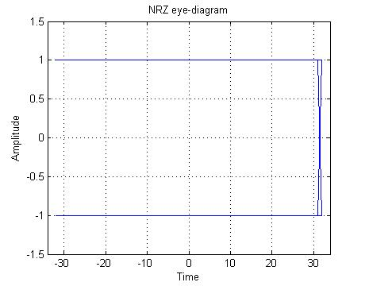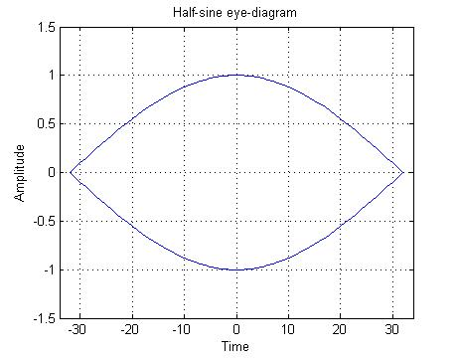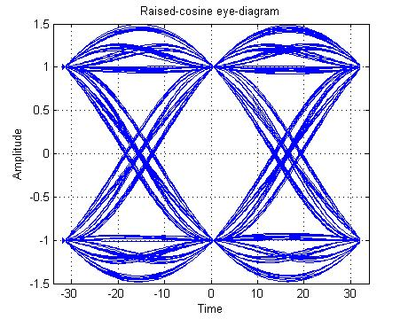
Result:

Experiment2

Pulse code modulation and demodulation

Aim: Simulate the Pulse code modulation and demodulation system and display the waveforms.
Theory: Pulse-code modulation (PCM) is a method used to digitally represent sampled analog signals. It is the standard form of digital audio in computers, compact discs, digital telephony and other digital audio applications. In a PCM stream, the amplitude of the analog signal is sampled regularly at uniform intervals, and each sample is quantized to the nearest value within a range of digital steps.
To recover the original signal from the sampled data, a "demodulator" can apply the procedure of modulation in reverse. After each sampling period, the demodulator reads the next value and shifts the output signal to the new value. As a result of these transitions, the signal has a significant amount of high-frequency energy caused by aliasing. To remove these undesirable frequencies and leave the original signal, the demodulator passes the signal through analog filters that suppress energy outside the expected frequency range.
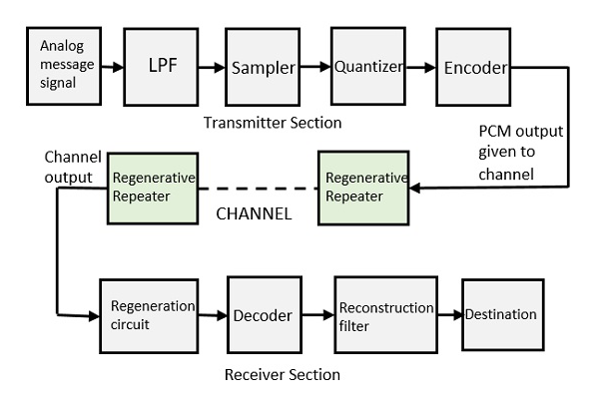
Code:
clc;
closeall;
clearall;

n = 4; % Number of bits i.e., 4-bit PCM
L = 2^n; % Number of levels
numSamples = 12; % Twelve samples in one period

% Sampling Operation
x=0:2*pi/numSamples:4*pi;
s=8*sin(x);
subplot(3,1,1);
plot(s);
title('Analog Signal');
ylabel('Amplitude');
xlabel('Time');
subplot(3,1,2);
stem(s);
gridon;
title('Sampled Sinal');
ylabel('Amplitude');
xlabel('Time');

% Quantization Process
vmax=8;
vmin=-vmax;
delta=(vmax-vmin)/L;
part=vmin:delta:vmax;
code=vmin-(delta/2):delta:vmax+(delta/2); % Contain Quantized values
[ind,q]=quantiz(s,part,code); % Quantization process
% ind contain index number and q contain quantized values
l1=length(ind);
l2=length(q);

for i=1:l1
if(ind(i)~=0) % To make index as binary decimal so started from 0 to N
ind(i)=ind(i)-1;
end
i=i+1;
end

for i=1:l2
if(q(i)==vmin-(delta/2)) % To make quantize value inbetween the levels
q(i)=vmin+(delta/2);
end
end
subplot(3,1,3);
stem(q);grid on; % Display the Quantize values
title('Quantized Signal');
ylabel('Amplitude');
xlabel('Time');

% Encoding Process
figure
code=dec2bin(ind); % Cnvert the decimal to binary
k=1;
for i=1:l1
for j=1:n
coded(k)=str2num(code(i,j)); % convert code matrix to a coded row vector
j=j+1;
k=k+1;
end
i=i+1;
end
subplot(2,1,1); grid on;
stairs(coded); % Display the encoded signal
axis([0 100 -2 3]); title('Encoded Signal');
ylabel('Amplitude');
xlabel('Time');

% Demodulation Of PCM signal

qunt=reshape(coded,n,length(coded)/n);
index=bin2dec(num2str(qunt')); % Getback the index in decimal form
q=delta*index+vmin+(delta/2); % getback Quantized values
subplot(2,1,2); grid on;
plot(q); % Plot Demodulated signal
title('Demodulated Signal');
ylabel('Amplitude');
xlabel('Time');
Procedure:
- Write the code using Matlab simulation tool.
- Verify the program and check out errors.
- Analyze the simulation output.
- Plot the graph/diagram using obtained output.

Waveforms: 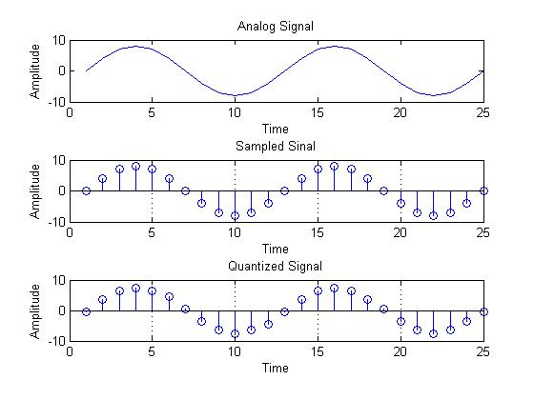
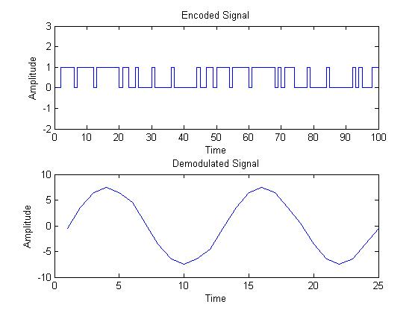

Result:

Experiment3
QPSK transmitter and receiver

Aim: Simulate the QPSK transmitter and receiver. Plot the signals and its constellation diagram.
Theory: The Quadrature Phase Shift Keying (QPSK) is a variation of BPSK, and it is also a Double Side Band Suppressed Carrier (DSBSC) modulation scheme, which sends two bits of digital information at a time, called as dibits.
Instead of the conversion of digital bits into a series of digital stream, it converts them into bit pairs. This decreases the data bit rate to half, which allows space for the other users.
Transmitter:
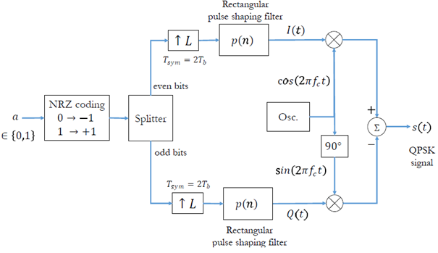
Receiver:
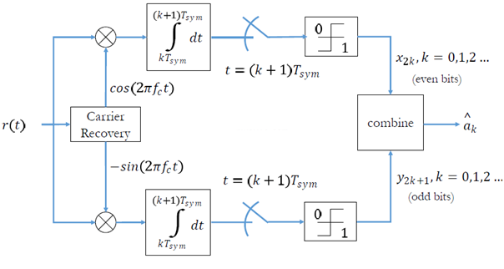
Code:
clc;
clearall;
closeall;

data=[0 1 0 1 1 1 0 0 1 1]; % data to be transmitted

figure(1)
stem(data, 'linewidth',3), grid on;
title(' Transmitted data ');
axis([ 0 11 0 1.5]);

data_NZR=2*data-1; % Data Represented at NZR form for QPSK modulation
s_p_data=reshape(data_NZR,2,length(data)/2); % S/P convertion of data

br=10.^6; %Assume bit rate 1000000
f=br; % carrier frequency
T=1/br; % bit duration
t=T/99:T/99:T; % Time vector for one bit information

% QPSK modulation
y=[];
y_in=[];
y_qd=[];
for(i=1:length(data)/2)
y1=s_p_data(1,i)*cos(2*pi*f*t); % inphase component
y2=s_p_data(2,i)*sin(2*pi*f*t) ;% Quadrature component
y_in=[y_in y1]; % inphase signal vector
y_qd=[y_qd y2]; %quadrature signal vector
y=[y y1+y2]; % modulated signal vector
end
Tx_sig=y; % transmitting signal after modulation
tt=T/99:T/99:(T*length(data))/2;

figure(2)
subplot(3,1,1);
plot(tt,y_in,'linewidth',3), grid on;
title(' wave form for inphase component in QPSK modulation ');
xlabel('time(sec)');
ylabel(' amplitude(volt0');

subplot(3,1,2);
plot(tt,y_qd,'linewidth',3), grid on;
title(' wave form for Quadrature component in QPSK modulation ');
xlabel('time(sec)');
ylabel(' amplitude(volt0');

subplot(3,1,3);
plot(tt,Tx_sig,'r','linewidth',3), grid on;
title('QPSK modulated signal (sum of inphase and Quadrature phase signal)');
xlabel('time(sec)');
ylabel(' amplitude(volt0');

% QPSK demodulation
Rx_data=[];
Rx_sig=Tx_sig; % Received signal
for(i=1:1:length(data)/2)

% inphase coherent detector
Z_in=Rx_sig((i-1)*length(t)+1:i*length(t)).*cos(2*pi*f*t);
% above line indicate multiplication of received &inphasecarred signal

Z_in_intg=(trapz(t,Z_in))*(2/T);% integration using trapizodial rule
if(Z_in_intg>0) % Decision
Rx_in_data=1;
else
Rx_in_data=0;
end

% Quadrature coherent detector
Z_qd=Rx_sig((i-1)*length(t)+1:i*length(t)).*sin(2*pi*f*t);
%above line indicate multiplication ofreceived&Quadphasecarred signal

Z_qd_intg=(trapz(t,Z_qd))*(2/T);%integration using trapizodial rule
if (Z_qd_intg>0)% Decision
Rx_qd_data=1;
else
Rx_qd_data=0;
end

Rx_data=[Rx_dataRx_in_dataRx_qd_data]; % Received Data vector
end

figure(3)
stem(Rx_data,'linewidth',3)
title(' Received data ');
axis([ 0 11 0 1.5]), grid on;
Procedure:
- Write the code using Matlab simulation tool.
- Verify the program and check out the errors.
- Analyze the simulation output.
- Plot the graph/diagram using obtained output.

Waveforms:
Data 0 1 0 1 1 1 0 0 1 1
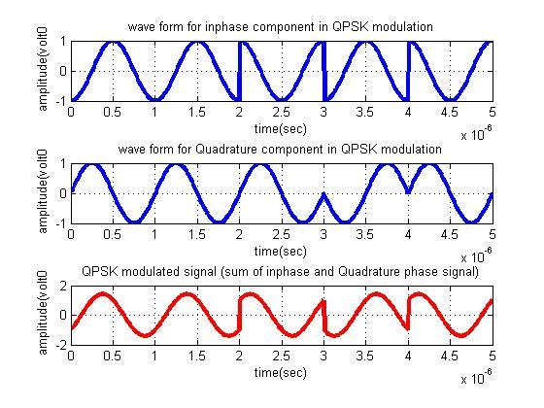

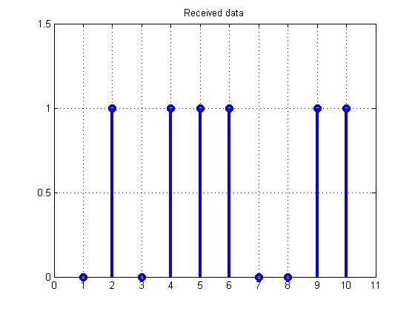

Experiment4

Test the performance of a binary DPSK

Aim: Test the performance of a binary differential phase shift keying system by simulating the non-coherent detection of binary DPSK.

Theory: In DPSK the information is carried in the difference between adjacent received phases. A DPSK receiver recovers the information by subtracting the phase of the previous sample from the phase of the current sample. Differential phase shift keying (DPSK) may be viewed as the non coherent version of PSK. Differential PSK is differentially coherent modulation method. It eliminates the need for a coherent reference signal at the receiver by combining two basic operations at the transmitter. Differential encoding of the input binary wave and phase shift keying- hence the name differential phase shift keying.
In Digital transmission the number of bit errors is the number of received bits of a data stream over a communication channel that has been altered due to noise, interference, distortion or bit synchronization errors. The bit error rate or bit error ratio (BER) is the number of bits in error divided by the total number of transferred bits during a studied time interval.
Probability of error for DBPSK is given by
P_{e}=1/2 exp(E_{b}/N₀)
where Eb/No is Signal to Noise ratio for DPSK
Code:
clc;
clearall;
closeall;

% Input data
N = 1e6; % number of bits or symbols
EbN0dB = 0:2:16; % multiple Eb/N0 values
M = 2; % DPSK constellation

% Constellation 2-DPSK
refArray = [ 1.0000 + 0.0000i 0.0000 + 1.0000i -1.0000 + 0.0000i -0.0000 - 1.0000i];

symErrSimulated = zeros(1,length(EbN0dB));
k = log2(M); % number of bits per symbol
EsN0dB = EbN0dB + 10*log10(k);

%â€”Generating a uniformly distributed random numbers in the set [0,1,2,..,2M-1]
data = 2*ceil(M.*rand(N,1))-1;

%â€”generating differential modulated symbols
% phi[k] = phi[k-1] + Dphi[k]
data_diff = filter(1,[1 -1],data); % start with 0 phase
s = refArray(mod(data_diff,2*M)+1);

%â€”Place holder for Symbol Error values for each Es/N0 for particular M valueâ€“
index =1;

for x = EsN0dB,
%â€”â€”â€”â€”â€”â€”â€”â€”â€”â€”â€”â€”â€”â€”-
%Channel Noise for various Es/N0
%â€”â€”â€”â€”â€”â€”â€”â€”â€”â€”â€”â€”â€”â€”-
%Adding noise with variance according to the required Es/N0
noiseVariance = 1/(10.^(x/10));%Standard deviation for AWGN Noise
noiseSigma = sqrt(noiseVariance/2);
%Creating a complex noise for adding with M-PSK modulated signal
%Noise is complex since M-PSK is in complex representation
noise = noiseSigma*(randn(1,N)+1i*randn(1,N));
received = s + noise; % additive white gaussian noise

%â€”â€”â€”â€”-I-Q Branchingâ€”â€”â€”â€”â€”
% non-coherent demodulation
estPhase = angle(received);
% Dphi[k] = phi[k] â€“ phi[k-1]
est_diffPhase = filter([1 -1],1,estPhase)*M/pi;

%â€”DecisionMaker-Computeâ€”â€”â€”â€”â€”
y = mod(2*floor(est_diffPhase/2)+1,2*M); % quantizing

%â€”â€”â€”â€”â€“Symbol Error Rate Calculationâ€”â€”â€”â€”â€”â€”â€”â€”â€”â€”-
symErrSimulated(1,index) = sum(y~=data')/(N*k);
index=index+1;
end

%â€”â€“ Compute Theoretical Symbol Error Rates â€”â€”â€”â€”â€”â€”â€”
%EsN0lin = 10.^(EsN0dB/10);
EbN0lin = 10.^(EbN0dB/10);
% Binary DPSK
symErrTheory = 0.5*exp(-EbN0lin);

€”Plottingcommands€”
figure;
semilogy(EbN0dB,symErrTheory,'b','LineWidth',1.5);hold on;
semilogy(EbN0dB,symErrSimulated,'r*','LineWidth',1.5);hold on;
legend({'Theory','Simulated'})
gridon;
xlabel('Eb/N0(dB)');
ylabel('Bit Error Rate (Pb)');
title('Simulation BER vs. Theoretical BER for Binary DPSK');
Procedure:
- Write the code using Matlab simulation tool.
- Verify the program and check out the errors.
- Analyze the simulation output.
- Plot the graph/diagram using obtained output.
Graph:

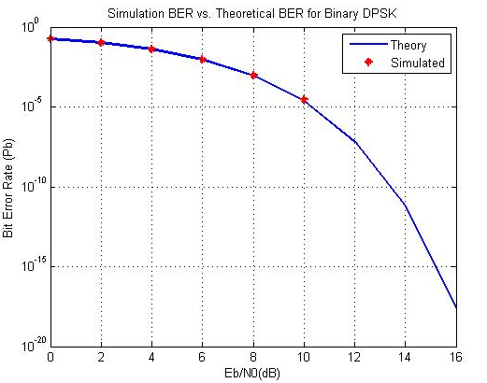

Additional questions:
- Design and verify the operation of ASK generator and demodulator.
- Study of propagation and bending loss in optical fiber.
- Study of numerical aperture of optical fiber.

